Currency Converter Documentation

Name: Pawar Rajani Baliram

Intern ID: VN-JD-4W293

Email: [rajanipawar6229@gmail.com](mailto:rajanipawar6229@gmail.com)

# Overview

The Currency Converter is a Java-based application that allows users to convert an amount from one currency to another.   
It utilizes an API (https://v6.exchangerate-api.com/) to fetch live exchange rates for various currencies and perform real-time currency conversions.

# Features

1. Convert Currency: Users can select the base currency, target currency, and the amount to be converted.  
2. Supported Currencies: The application supports a variety of currencies, including USD, EUR, GBP, INR, AUD, JPY, CNY, CAD, MXN, BRL, CHF, SEK, and NZD.  
3. Error Handling: Proper error messages are shown for invalid currency codes or API errors.

# Requirements

- Java Development Kit (JDK): Version 8 or higher.  
- Internet Connection: To access the live currency exchange API.  
- External Library: json-20210307.jar (for handling JSON responses from the API).  
- IDE: Visual Studio Code or any other Java IDE.

# Libraries Used

1. org.json: A JSON library used to parse and extract data from the API response.

# Installation & Setup

1. Download or Clone the Project: Download the source code or clone it from your repository.  
2. Install JDK: Ensure you have JDK 8 or higher installed on your machine. You can check your Java version by running:  
 java -version  
3. Add External Library: Download the json-20210307.jar file from the official repository and place it inside the libs folder in your project.  
4. Compile the Program: Navigate to the src folder and compile the program using the following command:  
 javac -cp .;libs/json-20210307.jar CurrencyConverter.java  
5. Run the Program: Run the program using this command:  
 java -cp .;libs/json-20210307.jar CurrencyConverter

# How It Works

1. User Interaction: The user is presented with a menu to choose whether to convert currency or exit.  
2. Currency Conversion: The program fetches live exchange rates for the base currency by calling the API (https://v6.exchangerate-api.com/v6/{API_KEY}/latest/{BASE_CURRENCY}).  
3. API Call: The API URL is dynamically generated based on the user's input for the base currency. The program makes an HTTP GET request to the API and receives a JSON response with conversion rates for all supported currencies.  
4. Error Handling: If an invalid currency code is entered, the user is prompted to try again. If there is an issue with the API request, an error message is displayed to the user.

# Supported Currencies

The following currencies are supported in the currency conversion:  
- USD: US Dollar  
- EUR: Euro  
- GBP: British Pound  
- INR: Indian Rupee  
- AUD: Australian Dollar  
- JPY: Japanese Yen  
- CNY: Chinese Yuan  
- CAD: Canadian Dollar  
- MXN: Mexican Peso  
- BRL: Brazilian Real  
- CHF: Swiss Franc  
- SEK: Swedish Krona  
- NZD: New Zealand Dollar

# Example:

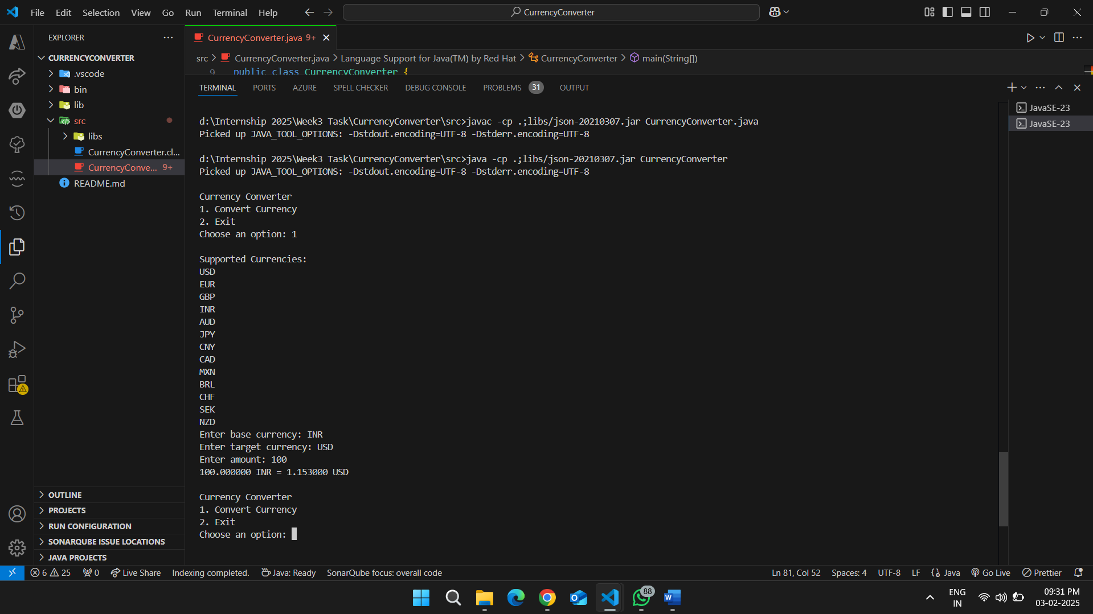Error Handling

1. Invalid Currency Code: If the user enters an invalid currency code, the program prompts them again to enter a valid code.  
2. API Connection Error: If the program is unable to connect to the API or encounters an error in retrieving data, the following message will appear:  
 Error: HTTP Response Code: 404

# Troubleshooting

1. Invalid JSON Parsing: Ensure the json-20210307.jar file is correctly placed in the libs folder.  
2. API Key Issues: If the API key is expired or invalid, the program will return a 404 or 403 HTTP response code.

# Conclusion

The Currency Converter program is a simple yet powerful tool for converting currencies using real-time exchange rates from an external API.   
It supports multiple currencies and ensures that the user is presented with valid options.   
This project can be further extended to support more currencies or additional features such as saving conversion history, converting multiple currencies at once, etc.